INTRODUCTION TO
WORKING EQUITATION CLINICS
TAUGHT BY
Champion Rider and Nationally licensed WE judge
Sue Watkins
SAT.-April 13 – Beginners / Sun. April 14 – Novice
MAR VAL Stables, 706 W. Lucas Rd. Lodi, CA 95242

Come learn all about the International sport of Working Equitation from Multiple Championship Rider, Carded Judge and National Technical Delegate Susan Watkins in a fun, relaxed, setting.
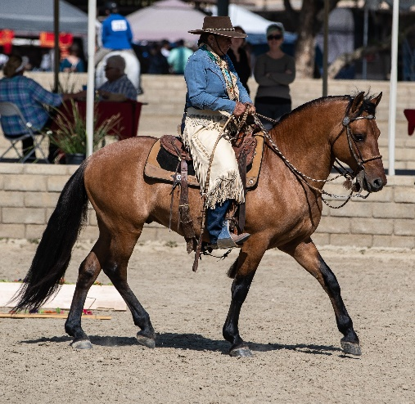

Phase 1: The Working Dressage test. Learn how to get started in the movements needed for a proper training foundation. What the judge is looking for and how to read and execute the tests.

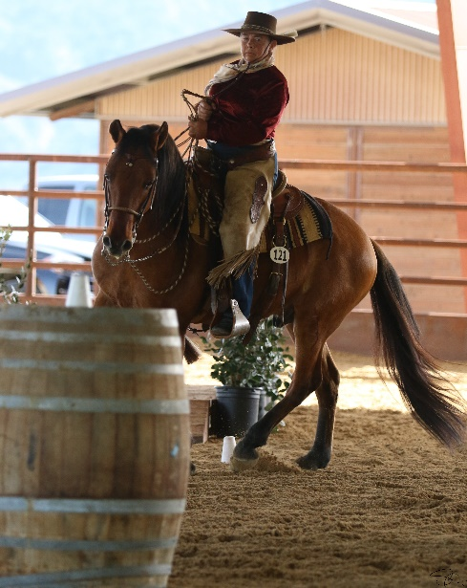

Phase 2: EOH – The Ease Of Handling test. What the 18 International Obstacles consist of, how to execute them properly. The accuracy needed for any type of obstacle competition. Understand the theory behind proper course navigation over and around the obstacles.

Phase 3: Speed and Phase 4: Cattle Handling will be explained in Opening Presentation. Go to weunited.us for rulebook and info.

- $125.oo per rider
- 9am – 4pm
- Auditors: $15.00
- max. 10 riders each clinic Day
- PRIVATE LESSONS AVAILABLE fRIDAY 4/12 OR MONDAY 4/15
- must register/pay in advance to reserve spot

For Reservations Contact: Nannette Tosh-Robb, 209-268-7731, ntoshrobb@sbcglobal.net
Facebook: MAR VAL Stables, EOTC.CA, Susan L. Watkins, USAWEA

